ST10291856 Mvelo Mkhize

Database Formation

CREATE TABLE Agent (

Agent_Id VARCHAR(5) PRIMARY KEY,

Agent_Name VARCHAR(50)

);

INSERT INTO Agent (Agent_Id, Agent_Name) VALUES

('ID01', 'Sli'),

('ID02', 'Bob'),

('ID03', 'Khaya'),

('ID04', 'Noxi'),

('ID05', 'Bongani');

CREATE TABLE Customer (

Cust_Id VARCHAR(5) PRIMARY KEY,

Cust_Name VARCHAR(50),

Suburb VARCHAR(50),

Budget DECIMAL(10, 2),

Agent_Id VARCHAR(5),

FOREIGN KEY (Agent_Id) REFERENCES Agent(Agent_Id)

);

INSERT INTO Customer (Cust_Id, Cust_Name, Suburb, Budget, Agent_Id) VALUES

('2454', 'Jackson,A', 'Sunningdale', 2500000.00, 'ID01'),

('S455', 'Smith,P', 'Inanda', 3000000.00, 'ID04'),

('2457', 'Naidoo,K', 'Pheonix', 1000000.00, 'ID04'),

('2453', 'Nomvette,A', 'Sunningdale', 4000000.00, 'ID04'),

('2459', 'Moodley,T', 'Pheonix', 1500000.00, 'ID02');

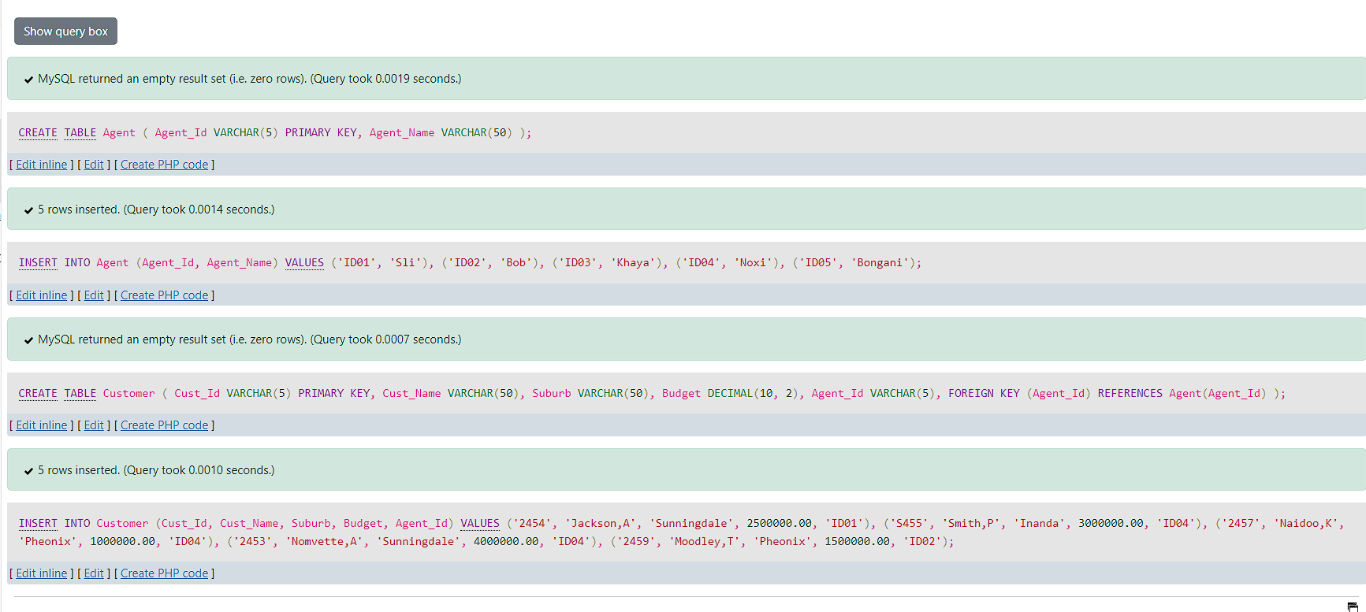

2.1.1

SELECT A.Agent_Name, COUNT(C.Cust_Id) AS Number_of_Clients

FROM Agent A

LEFT JOIN Customer C ON A.Agent_Id = C.Agent_Id

GROUP BY A.Agent_Name

ORDER BY Number_of_Clients DESC;

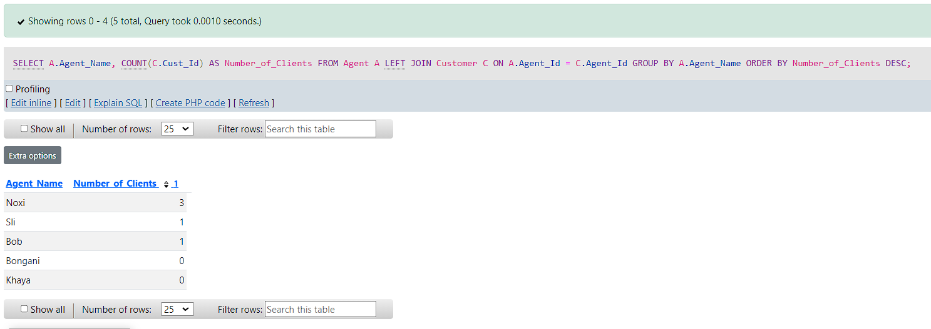

2.1.2

SELECT Agent_Id

FROM Agent

WHERE Agent_Id NOT IN (SELECT Agent_Id FROM Customer);

